

www.proscada.com

PO Box 417 Phone : +27 12 3482151
Newlands Fax : +27 12 3482151
0049 Cellular: +27 82 4596208
South Africa email :jon.pio@proscada.com

“I87” OPC Server IEC 870-5-103 Implementation guidlines

Unfortunately IEC 870-5-103 is a very poorly designed protocol, so some of these concepts are a little strange.

The Analog Address format is:

<Relay Name>:<function type>:<Information object>

The Digital Address format is:

<Relay Name>:<function type>:<Information object>:<bit>

Relay Name the name of the protection device, printable characters upto 11 characters long, may not include any of “:;, “

Function type Specifies the type of message, used together with the Information Object to Identify the data.

Information object Specifies the number of the value. ***NOTE when configuring the driver poll blocks the address of the start address corresponds to the IEC standard messages. When entering an address in a OPC client the Position number of the address is increments of 1 from this address.

Example Standard IEC data

RTU1:160:144 Current I
RTU1:160:145 Voltage V
RTU1:160:146 Power
RTU1:160:147 Q factor

RTU1:128:148 Current IL1
RTU1:128:149 Current IL2
RTU1:128:150 Current IL3
RTU1:128:151 Voltage IL1-e
RTU1:128:152 Voltage IL2-e
RTU1:128:153 Voltage IL3-e
RTU1:128:154 Power
RTU1:128:155 Q factor
RTU1:128:155 Frequency

These addresses will return the raw unscaled analog value, the value can be scaled either by the SCADA client OR the OPC server.

To scale the values in the OPC server add the following text to the address

|M103,<lo engineering unit>,<hi engineering unit>,<raw lo:raw hi>,<units optional>

example 1
a Reyrolle Relay scales 0 – 3412 so if the rated range is 100 amps
RTU1:160:144 |M103,0,100.0,0:3412,A

Example 2 Siemens Siprotec

Setup the driver poll blocks as follows:

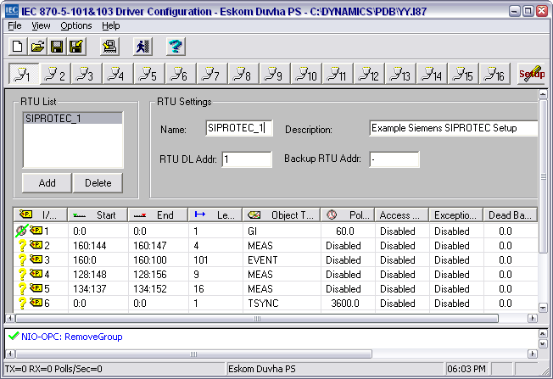

A Siemens SIPROTEC scales 1.7% to 240% with a raw range of 0-4095 and 100% = 1706

Current RTU1:134:137|M103,1.7,100.0,0:1706,%
Frequency RTU1:134:149|M103,47.0,53.0,0:4095,hz

Example Siemens SIProtec Non compatible data

Driver OPC Address | Siemens Measurand | Name | Descrption
RTU1:134:137|M103,1.7,100.0,0:1706,% | 601 | Ia | (Ia =) Measurement 134 137 No 3 1 CFC CD DD
RTU1:134:138|M103,1.7,100.0,0:1706,% | 602 | Ib | (Ib =) Measurement 134 137 No 3 2 CFC CD DD
RTU1:134:139|M103,1.7,100.0,0:1706,% | 603 | Ic | (Ic =) Measurement 134 137 No 9 3 CFC CD DD
RTU1:134:140|M103,1.7,100.0,0:1706,% | 604 | In | (In =) Measurement 134 137 No 9 4 CFC CD DD
RTU1:134:141|M103,1.7,100.0,0:1706,% | 621 | Va | (Va =) Measurement 134 137 No 9 5 CFC CD DD
RTU1:134:142|M103,1.7,100.0,0:1706,% | 622 | Vb | (Vb =) Measurement 134 137 No 9 6 CFC CD DD
RTU1:134:143|M103,1.7,100.0,0:1706,% | 623 | Vc | (Vc =) Measurement 134 137 No 9 7 CFC CD DD
RTU1:134:144|M103,1.7,100.0,0:1706,% | 624 | Va-b | (Va-b=) Measurement 134 137 No 9 8 CFC CD
RTU1:134:145|M103,1.7,100.0,0:1706,% | 625 | Vb-c | (Vb-c=) Measurement 134 137 No 9 9 CFC CD
RTU1:134:146|M103,1.7,100.0,0:1706,% | 626 | Vc-a | (Vc-a=) Measurement 134 137 No 9 10 CFC CD
RTU1:134:147|M103,1.7,100.0,0:1706,% | 641 | P | (active power) (P =) Measurement 134 137 No 9 11 CFC
RTU1:134:148|M103,1.7,100.0,0:1706,% | 642 | Q | (reactive power) (Q =) Measurement 134 137 No 9 12 CF
RTU1:134:149|M103,1.7,100.0,0:1706,% | 644 | Frequency | (Freq=) Measurement 134 137 No 9 13 C
RTU1:134:150|M103,1.7,100.0,0:1706,% | 901 | Power Factor | (PF =) 134 137 No 9 14
RTU1:134:151|M103,1.7,100.0,0:1706,% | 701 | Resistive ground current in isol systems (Ins Real) Measurement 134 137 No 9 15 CFC CD DD
RTU1:134:152|M103,1.7,100.0,0:1706,% | 702 | Reactive ground current in isol systems (Ins) Measurement 134 137 No 9 16 CFC CD DD

